**Program 1**

1. Python Program to Calculate the Area of Triangle, Square and Rectangle.

**Solution:**

*Triangle:*

import math

a=int(input("Enter first side: "))

b=int(input("Enter second side: "))

c=int(input("Enter third side: "))

s=(a+b+c)/2

area=math.sqrt(s*(s-a)*(s-b)*(s-c))

print("Area of the triangle is: ",round(area,2))

*Square:*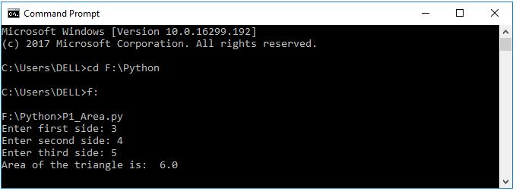

import math

a=int(input("Enter first side: "))

area=a**2

print("Area of the triangle is: ",round(area,2))

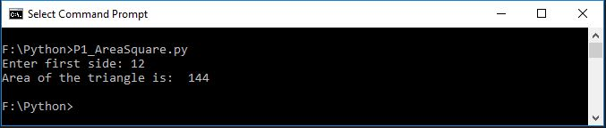

*Rectangle:*

import math

a=int(input("Enter first side: "))

b=int(input("Enter second side: "))

area=a*b

print("Area of the triangle is: ",round(area,2))

**Program 2**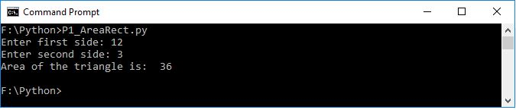

1. Python Program to Solve Quadratic Equation.

**Solution:**

import cmath

print('Solve the quadratic equation:')

a = float(input('Please enter a : '))

b = float(input('Please enter b : '))

c = float(input('Please enter c : '))

dell = (b**2) - (4*a*c)

sol_1 = (-b-cmath.sqrt(dell))/(2*a)

sol_2 = (-b+cmath.sqrt(dell))/(2*a)

print('The solutions are {0} and {1}'.format(sol_1,sol_2))

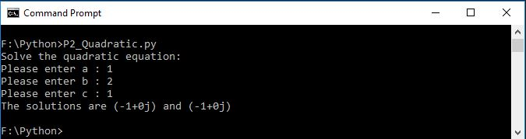

**Program 3**

1. Python Program to Swap Two Variables.

**Solution:**

a = 10

b = 20

print("before swapping\na=", a, " b=", b)

temp = a

a = b

b = temp

print("\nafter swapping\na=", a, " b=", b)

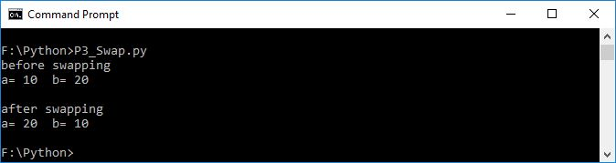

**Program 4**

1. Python Program to Generate a Random Numbers.

**Solution:**

import random

print(random.randint(0,9))

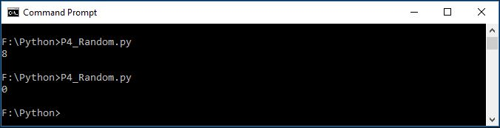

**Program 5**

1. Python Program to convert kilometers to miles, celsius to fahrenheit.

**Solution:**

*Kilometer to Miles:*

kilometers = float(input('Enter Values in Kilometers: '))

conv_fac = 0.621371

miles = kilometers * conv_fac

print('%0.3f kilometers is equal to %0.3f miles' %(kilometers,miles))

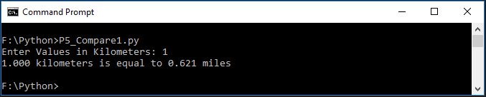

# *Celsius To Fahrenheit:*

cel = float(input('Enter Values in Celcious: '))

Farh = (cel * 1.8) + 32

print('%0.3f Celcious is equal to %0.3f Fahrenheit' %(cel,Farh))

